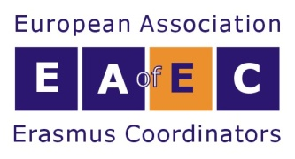

GENERAL ASSEMBLY 2023
Wednesday 20 September 2023, 18.00-19.00 EET
HYBRID

AGENDA
1. EAEC Activities 2022 – 2023 Report by the President
2. Financial Report until December 2022
3. Expression of interest for hosting ERACON 2024 and ERACON 2025
4. Evaluation of current activities and further development
5. Suggestions for new activities and plans, open discussion
6. Decision, if needed, on new Membership rates 2024 onwards
7. Main actions for 2023-2025
8. Elections of New Management Board Committee for 2023-2025
9. Appointed Executive Members of the Management Board 2023-2025
10. Other matters

